BABY PRODUCTS WEBSITE & APP PROJECT
Project Report
  - Duration:20 /3 – 28/3/ 2026
Developed by: Vetri IT Systems Pvt Ltd

Executive Summary
This project focuses on developing a Baby Products Website and Mobile Application using React (Frontend) and Django (Backend) frameworks, integrated with a modern UI design from Figma. The system allows customers to browse baby products, add them to cart, make secure purchases, and track orders.
The main objectives of this project are:
- Build a dynamic full-stack e-commerce application using React and Django.
- Implement secure user authentication and payment gateway integration.
- Provide CRUD operations for product listings and categories.
- Enable shopping cart and order management.
- Generate sales reports and analytics for Admin users.
- Provide an admin panel for managing products, customers, and orders.
This system demonstrates how a complete full-stack e-commerce solution can be developed using React, Django, and Figma design prototypes.

Project Team
Role | Name
Project Manager | Praveena
Designer | D. Karthigai Selvi
Developer | Bala Kannan A
Tester | Yoga Varshini

Technology Stack
Frontend | Backend | Database | Server
React, HTML, CSS, JavaScript, Bootstrap | Python (Django Framework) | SQLite | Django Development Server
.

Project Modules
Module | Description
Landing Page | Displays featured baby products, categories, and promotional banners.
Product | Add, update, delete product records • View product details • Assign categories dynamically.
User Auth | Django authentication system integrated with React frontend • User Registration • Login • Logout • Password change
Shopping Cart | Add products to cart • Update quantities • Remove items • Checkout process.
Order Management | Place orders • Track order status • View order history.
Profile & Address | Customers can update personal details: • Name • Mobile Number • Address • City • State • Zip code.
Reports & Analytics | Generate sales reports • Track customer activity • Export data for Admin
. Contact Page | Contact form (Name, Email, Message) • Messages stored in database • Viewable in Django Admin panel.

Key Highlights

✔ Fully functional Baby Products Website & App
✔ Responsive layout using React + Bootstrap
✔ Secure authentication and payment integration
✔ CRUD operations for products and categories
✔ Dynamic product display from database
✔ Shopping cart and order management
✔ Reports and analytics for Admin
✔ Contact form with database storage
✔ Django admin panel for organizational management

Project Code

import React, { useState, useEffect } from 'react';
import { Link } from 'react-router-dom';
import { ChevronLeft, ChevronRight, Star, ThumbsUp, ThumbsDown } from 'lucide-react';
// import ProductCard from '../components/ProductCard';
import api from '../services/api';
import './Home.css';
// New Arrival Images
import new1 from '../assets/new1.webp';
import new2 from '../assets/new2.webp';
import new3 from '../assets/new3.webp';
import new4 from '../assets/new4.webp';
import new5 from '../assets/new5.webp';
import new6 from '../assets/new6.webp';
import new7 from '../assets/new7.jpg';
import new8 from '../assets/new8.webp';

// Top Selling Images

import top1 from '../assets/top1.webp';
import top2 from '../assets/top2.webp';
import top3 from '../assets/top3.webp';
import top4 from '../assets/top4.webp';
import top5 from '../assets/top5.webp';
import top6 from '../assets/top6.webp';

const NEW_IMAGES = [new1, new2, new3, new4, new5, new6, new7, new8];
const TOP_IMAGES = [top1, top2, top3, top4, top5, top6,];
// ── Hero Slides ──
const HERO_SLIDES = [
{
badge: 'Flat 30% off',
title: 'Baby beds &',
subtitle: 'Accessories',
btn: 'Shop Now',
link: '/products?category=Newborn',
bg: 'linear-gradient(135deg, #ffe0f0 0%, #ffd6e8 100%)',
// உன் image: img: require('../assets/hero1.jpg')
img: 'https://images.unsplash.com/photo-1522771739844-6a9f6d5f14af?w=600&auto=format&fit=crop',
},
{
badge: 'New Launch',
title: 'Strollers &',
subtitle: 'Car Seats',
btn: 'Shop Now',
link: '/products?category=Gear',
bg: 'linear-gradient(135deg, #fff3cd 0%, #ffe8a0 100%)',
// உன் image: img: require('../assets/hero2.jpg')
img: 'https://images.unsplash.com/photo-1591088398332-8a7791972843?w=600&auto=format&fit=crop',
},
];

// ── Categories ──
// உன் images: img: require('../assets/boys.jpg') etc.
const CATEGORIES = [
{ name: 'Boys fashion', img: require('../assets/IMG_20250824_195106_608.jpg') , link: '/products?category=Baby Fashion ' },
{ name: 'Girls fashion', img: require('../assets/IMG_20250824_195115_947.jpg'), link: '/products?category=Baby Fashion' },
{ name: 'Footwear', img: require('../assets/20682525a.webp'), link: '/products?category=footwear' },
{ name: 'Accessories', img: require('../assets/IMG_20250824_195157_036.jpg'), link: '/products?category=Footwear' },
{ name: 'Toys', img: require('../assets/IMG_20250824_195229_011.jpg'), link: '/products?category=Toys' },
{ name: 'Beds', img: require('../assets/IMG_20250824_195307_666.jpg'), link: '/products?category=Beds' },
];

// ── Brands ──
const BRANDS = [
{ name: "Johnson's baby", color: '#e8f4fd', text: '#1565C0' },
{ name: 'Pampers', color: '#e3f2fd', text: '#0277BD' },
{ name: 'Babyking', color: '#fce4ec', text: '#C62828' },
{ name: 'KIDLON', color: '#f3e5f5', text: '#6A1B9A' },
{ name: "Tang's", color: '#fff8e1', text: '#F57F17' },
{ name: 'Mamaearth', color: '#e8f5e9', text: '#2E7D32' },
{ name: 'Himalaya', color: '#e0f2f1', text: '#00695C' },
{ name: 'Babyhug', color: '#fff3e0', text: '#E65100' },
];

// ── Testimonials ──
const TESTIMONIALS = [
{ name: 'Bosky', img: require('../assets/pngtree-cartoon-color-simple-male-avatar-png-image_1934459.jpg'), rating: 5, text: 'Very fast service and products are genuine..Definitely I am satisfied!', likes: 5, dislikes: 0 },
{ name: 'Tulip', img: require('../assets/4e22beef6d94640c45a1b15f4a158b23.jpg') , rating: 5, text: 'Amazing products. Reasonable prices. Gr8 customer service. Cheers !!!!!!', likes: 5, dislikes: 0 },
{ name: 'Deepa', img: require('../assets/beautiful-woman-avatar-character-icon-free-vector.jpg'), rating: 5, text: 'Great range of products right from new-born essentials … Excellent product quality and delivery', likes: 5, dislikes: 0 },
{ name: 'Moshin', img: require('../assets/thumb-1920-375571.png'), rating: 5, text: 'Great site for baby product, i m shopping here since 2012. The quality of product and services is never changed. Keep it up', likes: 5, dislikes: 0 },
];

export default function Home() {
const [slide, setSlide] = useState(0);
const [newArr, setNewArr] = useState([]);
const [topSell, setTopSell] = useState([]);
const [topIdx, setTopIdx] = useState(0);
const VISIBLE = 4;

useEffect(() => {
const t = setInterval(() => setSlide(s => (s + 1) % HERO_SLIDES.length), 4000);
return () => clearInterval(t);
}, []);

useEffect(() => {
api.get('/products/?ordering=-created_at&limit=8').then(r => setNewArr(r.data.results || r.data)).catch(() => {});
api.get('/products/?ordering=-reviews_count&limit=8').then(r => setTopSell(r.data.results || r.data)).catch(() => {});
}, []);

const cur = HERO_SLIDES[slide];

return (
<div className="home">

{/* ── Hero Slider ── */}
<section className="hero-slider" style={{ background: cur.bg }}>
{HERO_SLIDES.map((s, i) => (
<div key={i} className={`hero-slide ${i === slide ? 'active' : ''}`}>
<div className="container hero-slide-inner">
<div className="hero-text">
{s.badge && <div className="hero-badge">{s.badge}</div>}
<h1>{s.title}<br /><span>{s.subtitle}</span></h1>
<Link to={s.link} className="hero-btn">{s.btn}</Link>
</div>
<div className="hero-img-wrap">
<img src={s.img} alt={s.title} />
</div>
</div>
</div>
))}
<button className="slide-arrow left" onClick={() => setSlide(s => (s - 1 + HERO_SLIDES.length) % HERO_SLIDES.length)}><ChevronLeft size={22} /></button>
<button className="slide-arrow right" onClick={() => setSlide(s => (s + 1) % HERO_SLIDES.length)}><ChevronRight size={22} /></button>
<div className="slide-dots">
{HERO_SLIDES.map((_, i) => <button key={i} className={`dot ${i === slide ? 'active' : ''}`} onClick={() => setSlide(i)} />)}
</div>
</section>

{/* ── Categories ── */}
<section className="section">
<div className="container">
<h2 className="section-title" style={{textAlign:'center'}}>Categories</h2>

<div className="cat-grid">
{CATEGORIES.map(cat => (
<Link to={cat.link} key={cat.name} className="cat-card">
<div className="cat-img-oval">
<img src={cat.img} alt={cat.name} />
</div>
<p>{cat.name}</p>
</Link>
))}
</div>
<div className="cat-divider" />
</div>
</section>

{/* ── New Arrivals ── */}
<section className="section">
<div className="container">
<h2 className="section-title">New Arrivals</h2>

<div className="products-grid">
{newArr.length ? (
newArr.map((p, index) => (
<NewArrivalCard
key={p.id}
product={p}
customImg={NEW_IMAGES[index % NEW_IMAGES.length]}
/>
))
) : (
Array(8)
.fill(0)
.map((_, i) => <div key={i} className="skeleton-card" />)
)}
</div>

</div>
</section>

{/* ── Top Selling slider ── */}
<section className="section bg-pink-light">
<div className="container">
<div className="section-header">
<h2 className="section-title">Top selling</h2>
<Link to="/products?ordering=-reviews_count" className="view-all-btn">View All →</Link>
</div>
<div className="slider-wrap">
{topIdx > 0 && <button className="slider-arrow left" onClick={() => setTopIdx(i => Math.max(0, i - 1))}><ChevronLeft size={20} /></button>}
<div className="slider-viewport">
<div className="slider-track" style={{ transform: `translateX(-${topIdx * 25}%)` }}>
{topSell.map((p, index) => (
<div key={p.id} className="slider-item">
<div className="top-sell-card">
<div className="ts-img">
<img src={TOP_IMAGES[index % TOP_IMAGES.length] || p.image} />
</div>
<h3>{p.name}</h3>
<Link to={`/products/${p.id}`} className="shop-now-btn">Shop Now</Link>
</div>
</div>
))}
</div>
</div>
{topSell.length > VISIBLE && topIdx < topSell.length - VISIBLE && (
<button className="slider-arrow right" onClick={() => setTopIdx(i => i + 1)}><ChevronRight size={20} /></button>
)}
</div>
</div>
</section>

{/* ── Top Brands ── */}
<section className="section">
<div className="container">
<h2 className="section-title">Top Brands</h2>
<div className="brands-track-wrap">
<div className="brands-track">
{[...BRANDS, ...BRANDS].map((b, i) => (
<div key={i} className="brand-card" style={{ background: b.color }}>
<span style={{ color: b.text, fontWeight: 700, fontSize: 15 }}>{b.name}</span>
</div>
))}
</div>
</div>
</div>
</section>

{/* ── Happy Customers ── */}
<section className="section">
<div className="container">
<h2 className="section-title" style={{textAlign:'center'}}>Our happy customer</h2>
<div className="testimonials-grid">
{TESTIMONIALS.map((t, i) => (
<div key={i} className="testimonial-card">
{/* <div className="t-avatar" style={{ background: t.color }}>
{t.name[0]}
</div> */}
<div className="t-avatar">
<img src={t.img} alt={t.name} style={{width:'100%', height:'100%', objectFit:'cover', borderRadius:'50%'}} />
</div>
<h3>{t.name}</h3>
<div className="t-stars">
{Array(t.rating).fill(0).map((_, s) => <Star key={s} size={16} fill="#FFB300" color="#FFB300" />)}
</div>
<p>{t.text}</p>
<div className="t-actions">
<span><ThumbsDown size={14} /> {t.dislikes}</span>
<span><ThumbsUp size={14} /> {t.likes}</span>
</div>
</div>
))}
</div>
<div style={{ textAlign: 'right', marginTop: 16 }}>
<button className="view-more-btn">View More</button>
</div>
</div>
</section>

{/* ── Footer ── */}
<footer className="footer">
<div className="container footer-grid">
<div className="footer-brand">
<div style={{display:'flex',flexDirection:'column',alignItems:'flex-start',gap:'4px',marginBottom:'12px'}}>
<img src={require('../assets/IMG_20250821_174843_910-removebg-preview.png')} alt="baby" style={{width:80,height:80,objectFit:'contain'}} />
{/* <img src={require('../assets/IMG_20250821_174843_910-removebg-preview (1).png')} alt="BabyBliss" style={{width:100,objectFit:'contain',marginTop:'-8px'}} /> */}
</div>
<p>4th street, pallavaram,<br />Near bus stand<br />Madurai-234567</p>
</div>
<div><h3>Top categories</h3><Link to="/products?category=Baby Fashion">Baby Fashion</Link><Link to="/products?category=Toys">Toys</Link><Link to="/products?category=Footwear">Footwear & Accessories</Link><Link to="/products?category=Feeding">Moms & Baby care</Link><Link to="/products?category=Beds">Furniture & Bedding</Link><Link to="/products?category=Rider">Rental services</Link></div>
<div><h3>Customer support</h3><a href="#">Help & contact us</a><a href="#">Delivery information</a><a href="#">Track your order</a><a href="#">Returns & exchange</a><a href="#">Promotion Terms & conditions</a><a href="#">Terms & conditions</a></div>
<div><h3>Useful Links</h3><a href="#">Store finder</a><a href="#">Sitemap</a><a href="#">Fees and payments policy</a></div>
<div><h3>About BabyZone</h3><a href="#">Privacy Policy</a><a href="#">Terms & conditions</a></div>
<div>
<h3>Social Media</h3>
<div className="social-icons">
<a href="#" style={{background:'#1877F2',color:'white',width:36,height:36,borderRadius:8,display:'flex',alignItems:'center',justifyContent:'center',fontWeight:700,fontSize:16}}>f</a>
<a href="#" style={{background:'linear-gradient(45deg,#f09433,#e6683c,#dc2743)',color:'white',width:36,height:36,borderRadius:8,display:'flex',alignItems:'center',justifyContent:'center',fontSize:16}}>📷</a>
<a href="#" style={{background:'#1DA1F2',color:'white',width:36,height:36,borderRadius:8,display:'flex',alignItems:'center',justifyContent:'center',fontSize:16}}>🐦</a>
<a href="#" style={{background:'#FF0000',color:'white',width:36,height:36,borderRadius:8,display:'flex',alignItems:'center',justifyContent:'center',fontSize:16}}>▶</a>
</div>
</div>
</div>
</footer>
</div>
);
}

// New Arrival Card Component

function NewArrivalCard({ product, customImg }) {
const imgSrc = customImg || product.image || `https://via.placeholder.com/300`;

return (
<Link to={`/products/${product.id}`} className="na-card">
<div className="na-img">
<img src={imgSrc} alt={product.name} />
</div>
<div className="na-info">
<h3>{product.name}</h3>
<p>MRP: ₹ {product.price}</p>
<button className="buy-btn">Buy</button>
</div>
</Link>
);
}

Project Screenshots
Sample screenshots from the BABY WEBSITE

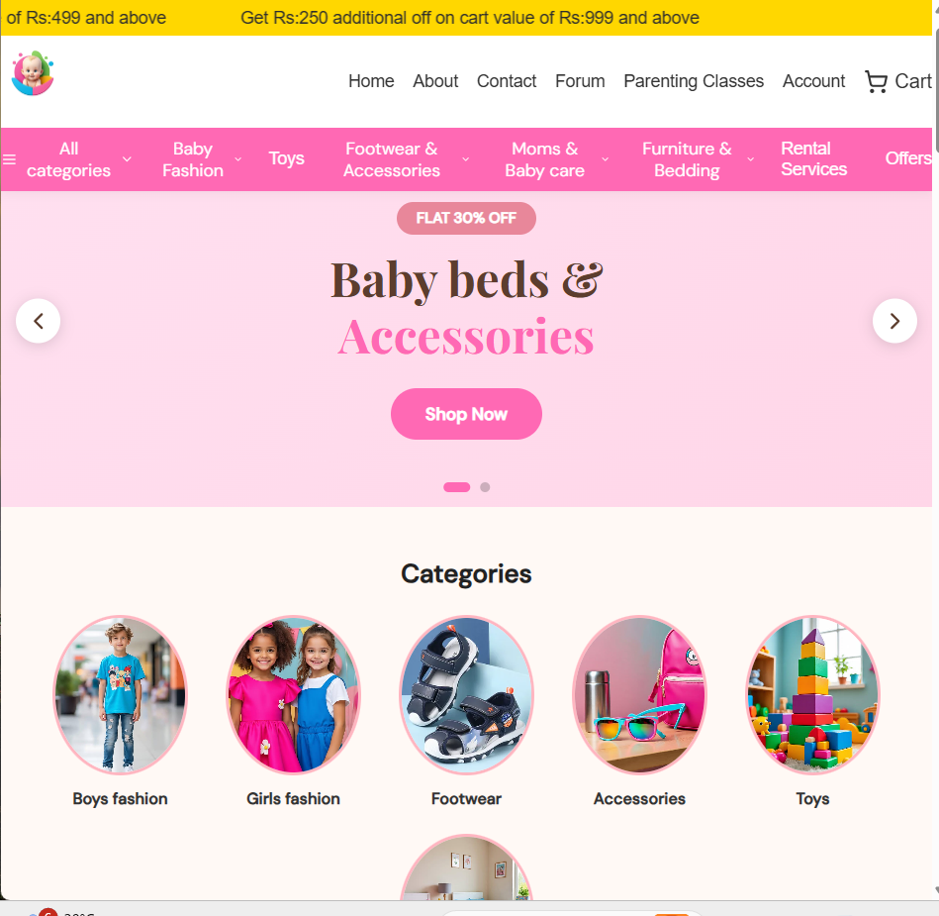

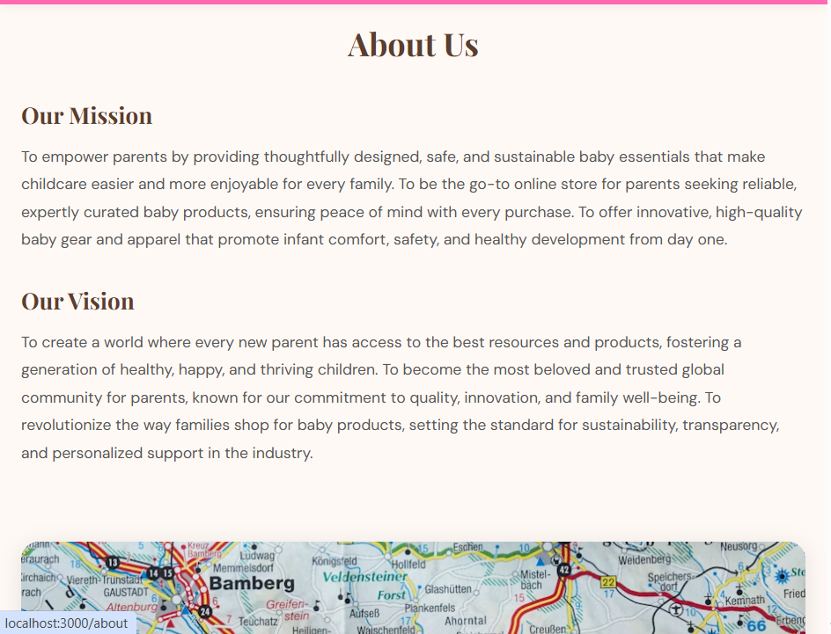

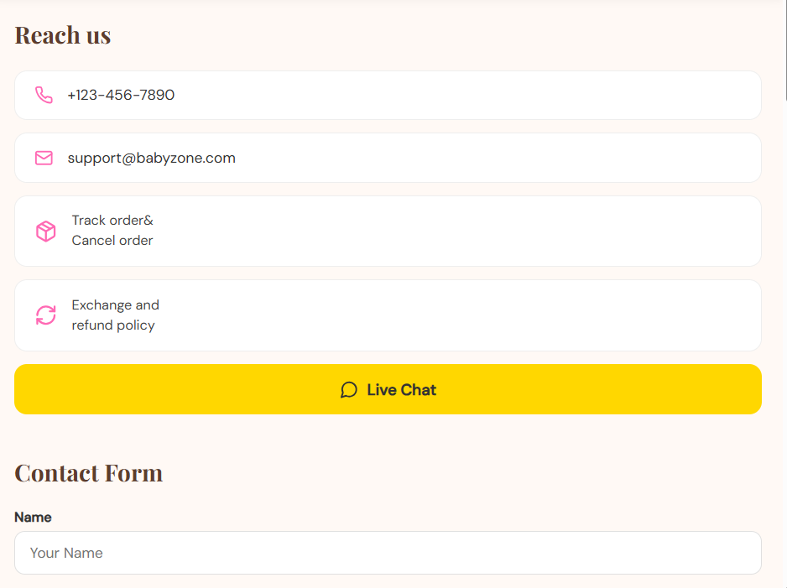

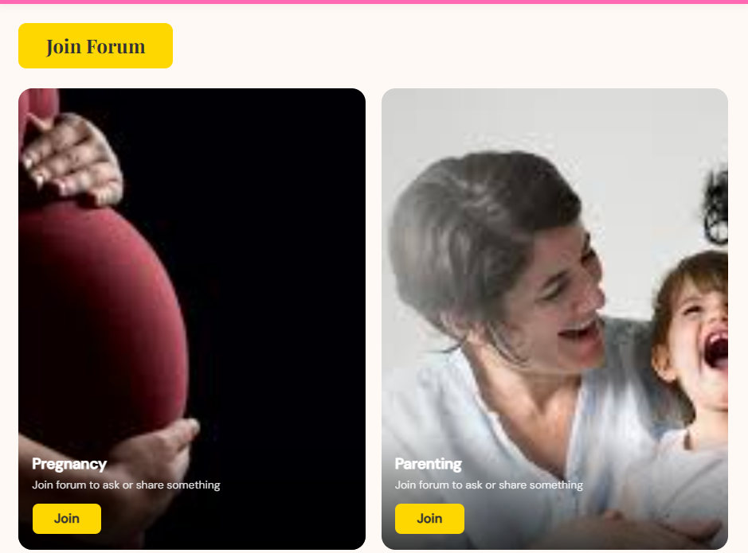

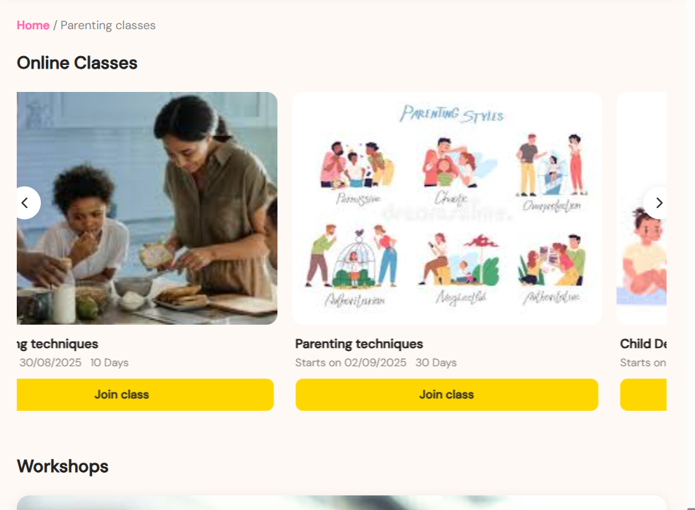

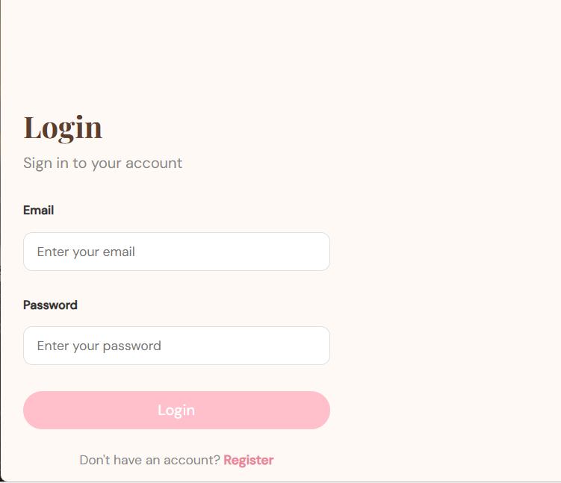

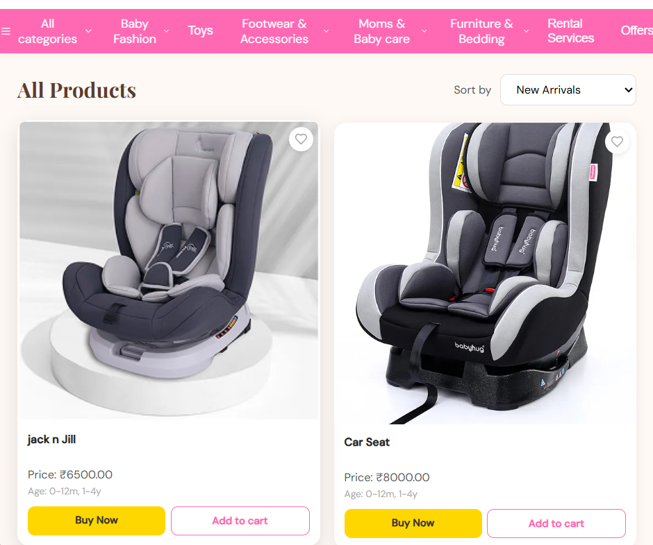

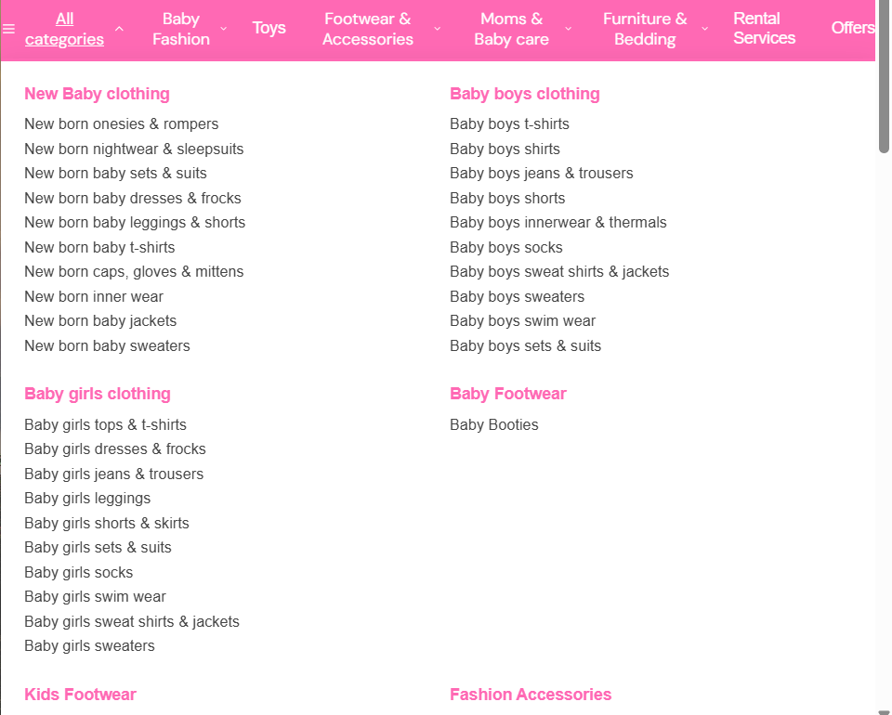

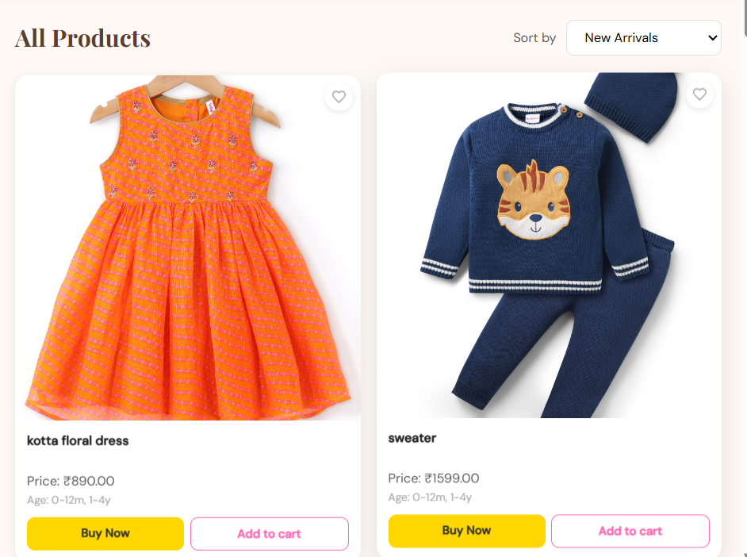

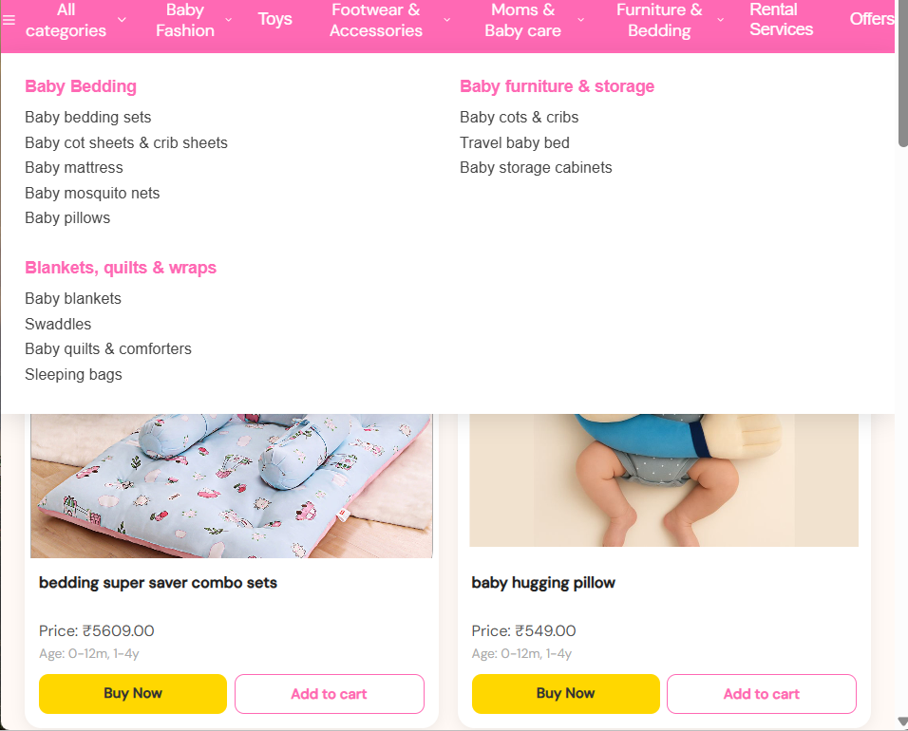

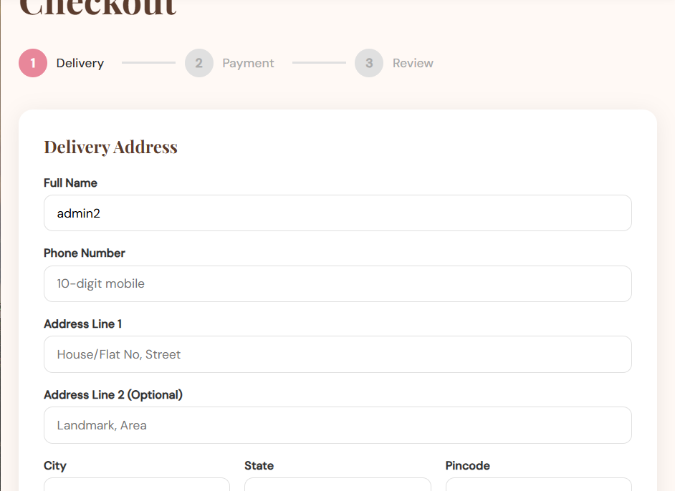

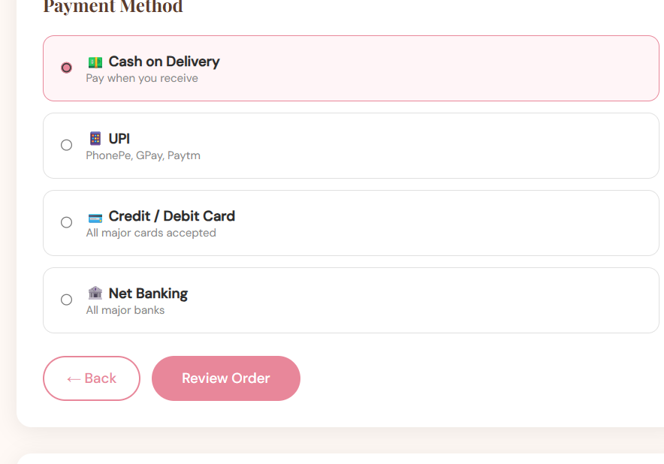

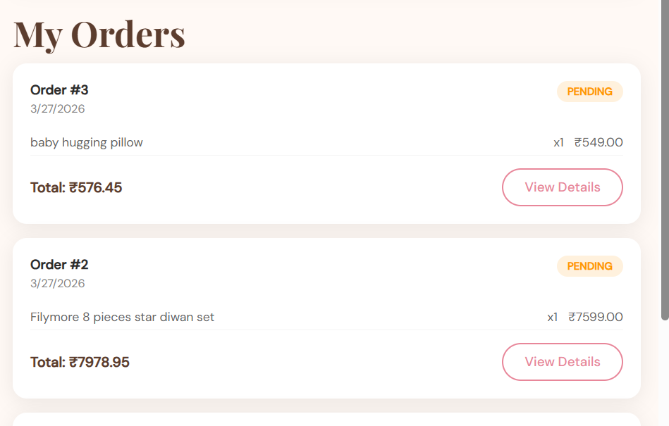
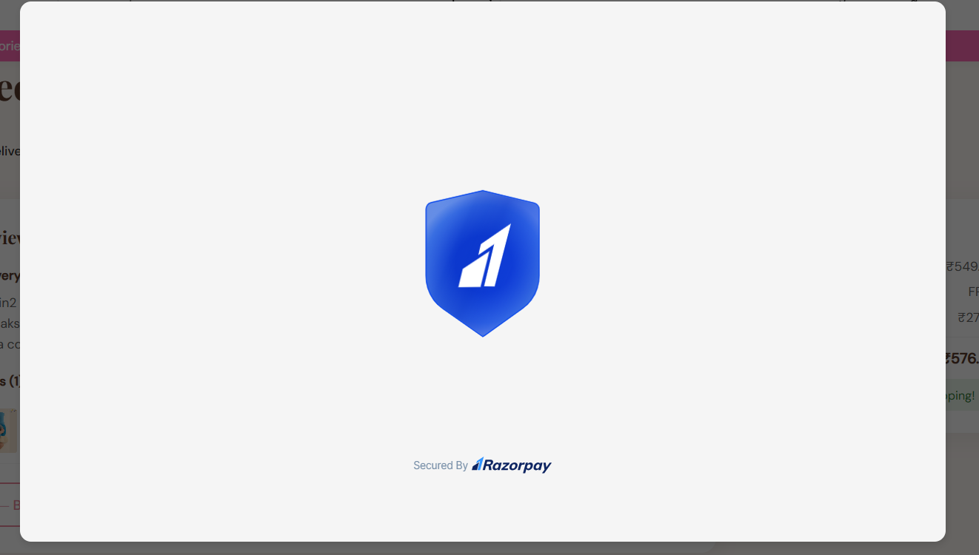

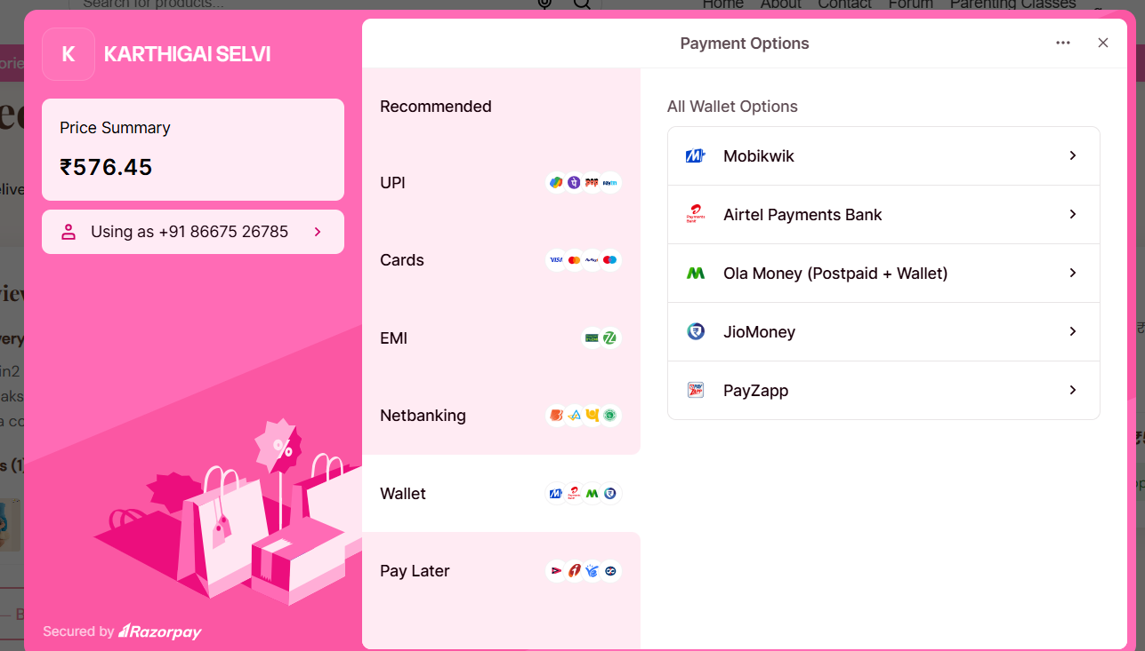

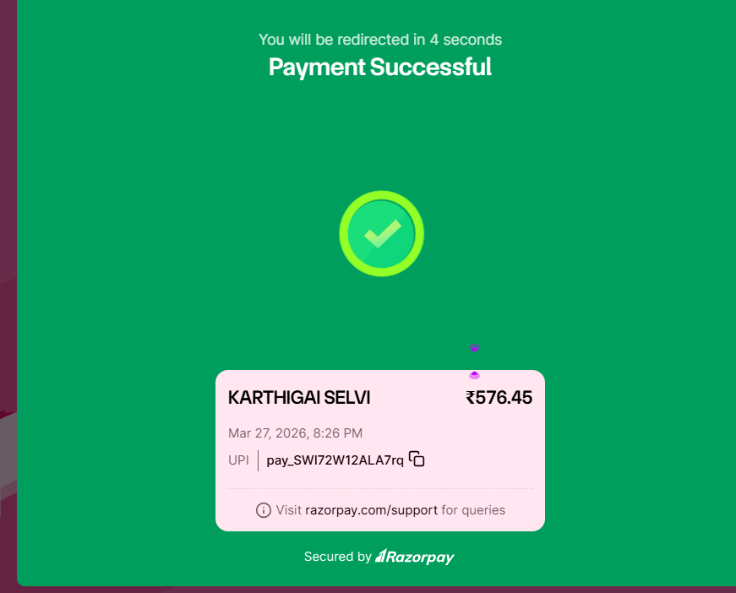

Conclusion:
The Baby Products Website & App project successfully demonstrates the development of a complete full-stack e-commerce application using React and Django, guided by Figma design prototypes.
This project improves:
- Backend development using Django REST Framework.
- Database management with models and APIs.
- Authentication and payment gateway integration.
- Full-stack application structure with React frontend.
Future Enhancements:
- Loyalty points and rewards system.
- Push notifications for order updates.
- Advanced analytics dashboard.
- Deployment on cloud hosting.
.

